**Project Documentation**

**CookBook: Your Virtual Kitchen Assistant**

**1.Introduction**

• **Project Title**: CookBook: Your Virtual Kitchen Assistant

• **Team ID**: NM2025TMID38606

• **Team Leader**: Sripriya R R & Mail id: sripriyarr2712@gmail.com

• **Team Members**:

– Divya B & Mail id: divya20050501@gmail.com

– Kirthiga G& Mail id: kirthigahari2019@gmail.com

– Radhika R & Mail id: radhikamurugan29133@gmail.com

**2.Project Overview**

**Purpose:** CookBook is a web-based application developed using React.js that serves as a virtual kitchen assistant. The platform allows users to discover, save, and manage a variety of recipes in one place. It offers features such as recipe search, ingredient-based suggestions,step-by-step cooking instructions, and the ability to create a personalized digital cookbook**.**

**Features:**

* **Recipe Search:** Search for recipes by name, ingredient, or category using a dynamic search bar.
* **Ingredient-Based Suggestions:** Get recipe recommendations based on available ingredients entered by the user.
* **Step-by-Step Instructions:** Detailed cooking steps are displayed in a clear, easy-to-follow format.
* **Save Favorite Recipes:**Users can bookmark or save recipes to access later in their personalized cookbook.
* **Responsive Design:** Fully responsive UI that works seamlessly on desktops, tablets, and mobile devices.
* **User-Friendly Interface:** Clean and intuitive layout built with reusable React components.
* **Filter and Sort Options:** Filter recipes by cuisine, cooking time, diet (e.g., vegetarian, vegan), or difficulty level.
* **Recipe Details Page:** View recipe images, ingredients, preparation steps, cook time, and servings on a dedicated page.
* **Local Storage Integration:** Saves user preferences and favorites locally so data persists across sessions.

**3. Architecture**

* **Component Structure:**

**- Navbar**: Displays navigation links such as Home, Add Recipe, and Favorites.

**- SearchBar**: Allows users to filter recipes by name, ingredient, or category.

**- RecipeCard:** Renders a visual preview of a recipe including title, image, and summary.

**- RecipeForm:** Provides a form interface for users to submit new recipes.

* **State Management**:

**- recipes**: An array containing all available recipes.

**- favorites**: An array of recipe IDs marked as favorites by the user**.**

**- theme**: A string representing the current theme mode, either "light" or "dark".

* **Routing:**

-React Router routes for your CookBook: Your Virtual Kitchen Assistant app, using dynamic paths for recipe categories and individual recipe pages:

**New page**

<Routes>

<Route path="/" element={<Home />} />

<Route path="/category/:categoryId" element={<CategoryPage />} />

<Route path="/recipe/:recipeId" element={<RecipePage />} />

<Route path="/add" element={<AddRecipePage />} />

<Route path="/favorites" element={<FavoritesPage />} />

</Routes>

**4. Setup Instructions**

• **Prerequisites**:

– Node.js

– Visual Studio Code

– Git

• **Installation Steps**:

Clone the repository git clone

– git clone <your-repo-url>

– cd insightstream

– npm install

– npm start

**5. Folder Structure**

cookbook-app/

├── public/

│ └── index.html

├── src/

│ ├── assets/ # Images, icons, fonts

│ ├── components/ # Reusable UI components (e.g., Button, Card)

│ ├── features/ # Domain-specific logic (e.g., recipes, favorites)

│ │ ├── recipes/

│ │ │ ├── RecipeCard.jsx

│ │ │ ├── RecipeForm.jsx

│ │ │ └── recipeSlice.js

│ │ ├── categories/

│ │ │ ├── CategoryList.jsx

│ │ │ └── categorySlice.js

│ │ └── favorites/

│ │ ├── FavoritesList.jsx

│ │ └── favoritesSlice.js

│ ├── pages/ # Route-based views

│ │ ├── Home.jsx

│ │ ├── CategoryPage.jsx

│ │ ├── RecipePage.jsx

│ │ ├── AddRecipePage.jsx

│ │ └── FavoritesPage.jsx

│ ├── routes/ # Centralized route definitions

│ │ └── AppRoutes.jsx

│ ├── services/ # API calls and external integrations

│ │ └── recipeService.js

│ ├── context/ # Global state (if using Context API)

│ │ └── ThemeContext.js

│ ├── hooks/ # Custom React hooks

│ │ └── useLocalStorage.js

│ ├── utils/ # Helper functions

│ │ └── formatDate.js

│ ├── styles/ # Global and modular styles

│ │ └── main.css

│ ├── App.jsx # Main app component

│ └── index.js # Entry point

├── .env # Environment variables

├── package.json

└── README.md

**6. Running the Application**

• **Install dependencies**:

• npm install

• **Start the app**:

▪ npm start

• **Access:** Visit http://localhost:3000

**7. State Management**

● **Global State**: GeneralContext.jsx manages shared data like selected category or theme.

**● Local State**: Each page/component uses useState for API responses and UI control.

**8. Component Documentation**

**App Component**

* **File**: App.js
* **Description**: Root component that manages routing and global state.
* **Props**: None
* **State**:

- recipes → Stores list of all recipes.

- favorites → Stores user’s favorite recipes.

* **Children:**

- <Header />

- <RecipeList />

- <RecipeDetail /> (via router)

- <Footer />

**Header Component**

* **File**: Header.js
* **Description:** Displays app logo, navigation links, and search bar.
* **Props**: onSearch(query: string) → Callback to handle search input.
* **State:** searchQuery → Current value of search input**.**
* **Children: None**

**RecipeList Component**

* **File**: RecipeList.js
* **Description:** Displays a grid/list of recipe cards**.**
* **Props**: recipes:

Array<Recipe> → List of recipe objects to render.

onSelectRecipe(id: number) → Callback when a recipe is clicked.

* **State**: None

**RecipeCard Component**

* **File:** RecipeCard.js
* **Description**: Shows a single recipe preview (image, name, short description).
* **Props:**

recipe: Recipe → Recipe object with id, title, image, time, category.

onClick(id: number) → Handle recipe selection**.**

* **State:** None

**RecipeDetail Component**

* **File:** RecipeDetail.js
* **Description**: Displays detailed recipe info (ingredients, steps, cooking time).
* **Props:**

recipe: Recipe → Full recipe details.

onAddFavorite(recipe: Recipe) → Add recipe to favorites.

* **State:**

isFavorite: boolean → Tracks if recipe is in favorites.

* **Children:**None

**Favorites Component**

* **File:** Favorites.js
* **Description:** Shows a user’s saved favorite recipes**.**
* **Props:**

**favorites: Array<Recipe> → List of favorite recipes.**

**onRemoveFavorite(id: number) → Remove recipe from favorites.**

* **State:** None
* **Children: <RecipeCard />**

**AddRecipe Component**

* **File:** AddRecipe.js
* **Description:** Form for adding a new recipe**.**
* **Props:**

onAdd(recipe: Recipe) → Callback to add new recipe**.**

* **State:**

title, ingredients, steps, category, image (form inputs).

* **Children:** None

**Footer Component**

* **File:** Footer.js
* **Description:** Footer with copyright info and links**.**
* **Props:** None
* **State:** None

**SearchBar Component**

* **File:** SearchBar.js
* **Description:** Handles recipe search queries**.**
* **Props:**

onSearch(query: string) → Callback when search submitted**.**

* **State:**

query: string → Controlled input field.

* **Children:** None

**Utility Components**

* **Loader.js** → Loading spinner.
* **ErrorBoundary.js** → Handles unexpected errors gracefully.
* **Modal.js** → For displaying dialogs (like recipe edit, confirm delete).Component Documentation

**9. User Interface**

**Screens and flows:**

**● Home**: Navbar → Hero → TopStories → Newsletter → Footer

**● Category:** Title → Articles grid → Pagination

**● News details :** Inline details or redirect to external URL

**Accessibility and UX:**

**●** Readable font sizes, alt text on images, keyboard focus on links

● Consistent spacing, clear hierarchy, mobile-first layout

● Clean layout with cards and grids

● Responsive design for mobile and desktop

● Visual hierarchy using headlines and thumbnails

● Accessible color contrast and readable font

**10. Styling**

**CSS approach:**

● **Plain CSS files**: One per component/page under “styles/”

● **Naming**: Class names for readability and reuse.

**Optional libraries**:

● **Bootstrap or Material UI**: Can be added for grids and responsive utilities

**Theming**:

● **Future toggle**: dark/light using context and CSS variables

**11. Testing**

**Testing strategy**:

● Manual testing in Chrome and Firefox

● Console logging for API errors

● Responsive layout checks

● Future: Jest for unit testing (App.test.js, setupTests.js)

**Suggested coverage targets**:

● Core components: Navbar, ArticleCard, TopStories

● Pages: Home and CategoryPage render states (loading/error/success)

**12. Known Issues**

* **Routing Errors** – Navigating between recipe list and recipe detail pages may break if React Router is not configured correctly.
* **Data Persistence** – Favorites and added recipes may not stay after refresh if localStorage, IndexedDB, or a backend API is not implemented.
* **Image Handling** – Recipe images may load slowly, break, or appear stretched if not optimized with proper styling and responsive design.
* **Form Validation** – The add recipe form may allow incomplete or invalid entries without validation rules.
* **Responsive Design** – Layout may look fine on desktop but break on mobile or tablets without proper media queries or flex/grid usage.
* **Error Handling** – API calls or local storage access may fail, and without an ErrorBoundary or fallback UI, the app could crash.
* **Accessibility Issues** – Missing alt text for images, poor color contrast, or lack of keyboard navigation may reduce usability.
* **Component Re-rendering –** Unnecessary re-renders can cause performance lags, especially when displaying many recipe cards.
* **Cross-Browser Compatibility** – Certain CSS features or layouts may not behave consistently across Chrome, Firefox, Safari, etc.
* **Security Concerns** – If users can add recipes, inputs may be vulnerable to XSS without sanitization.

**13.Future Enhancements**

* **User Authentication** – Allow users to create accounts, save their recipes, and sync favorites across devices.
* **AI Recipe Suggestions** – Integrate an AI model to suggest recipes based on ingredients users already have at home.
* **Voice Assistant Integration** – Add voice commands for searching, reading out steps, or guiding users while cooking hands-free.
* **Meal Planner** – Provide a weekly meal planner with automatic shopping list generation.
* **Nutritional Info** – Show calorie counts and nutritional breakdown for each recipe.
* **Advanced Search & Filters** – Filter recipes by cuisine, cooking time, dietary restrictions (vegan, gluten-free, etc.).
* **Social Sharing** – Enable users to share recipes directly to social media or export as a printable PDF.
* **Rating & Reviews** – Let users rate recipes and leave feedback to improve recommendations.
* **Step-by-Step Cooking Mode** – Full-screen guided cooking steps with timers and voice narration.
* **Offline Support** – Allow recipe browsing without internet using service workers and caching.
* **Push Notifications** – Reminders for meal prep, cooking timers, or new recipe suggestions.

**14. API Integration**

**Base endpoint**:

● Everything endpoint with query:

https://newsapi.org/v2/everything?q={query}&apiKey={key}

**Environment:**

● Use process.env for API key

● Respect API rate limits and errors

**• Code**:

import axios from 'axios';

const api = axios.create({

baseURL: 'https://newsapi.org/v2',

params: { apiKey: process.env.REACT_APP_NEWS_API_KEY },

});

**15.Screenshots or Demo**

**Home Page**

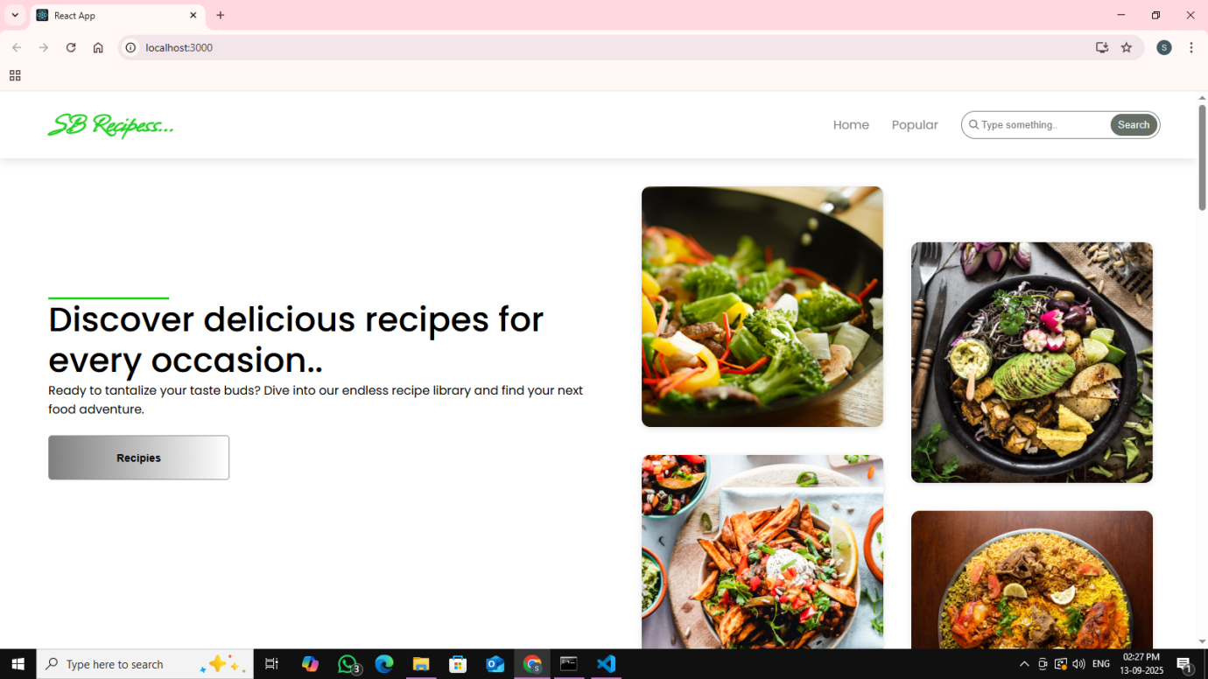

**Categories**

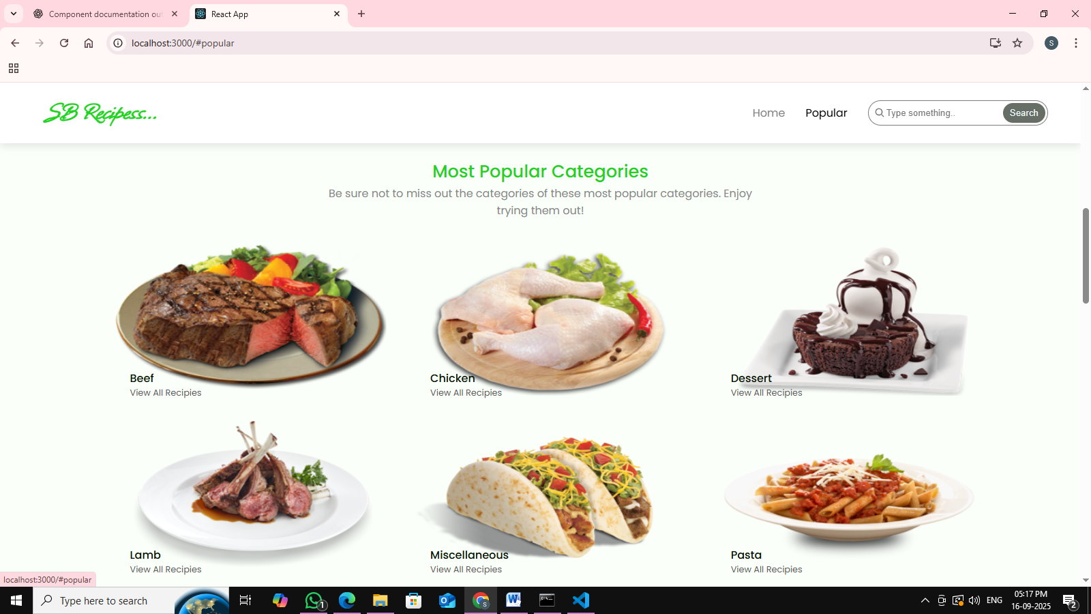

**Recipes List**

